**Ideation Phase**

**Define the Problem Statements**

|  |  |
| --- | --- |
| Date | 31 June 2025 |
| Team ID | LTVIP2025TMID41359 |
| Project Name | Hematovision: Advanced Blood Cell Classification |
| Maximum Marks | 2 Marks |

**Hematovision Problem Statement Template:**

The accurate identification and classification of blood cells are critical for diagnosing various hematological disorders, such as anemia, leukemia, and infections. Manual microscopic analysis of blood smears, while effective, is time-consuming, labor-intensive, and prone to human error due to variability in expertise and fatigue. Existing automated systems often lack the precision and robustness needed to handle diverse blood cell types and abnormalities under varying imaging conditions. There is a pressing need for an advanced, automated blood cell classification system that leverages cutting-edge machine learning techniques to provide accurate, efficient, and scalable analysis of blood smears for medical diagnostics.

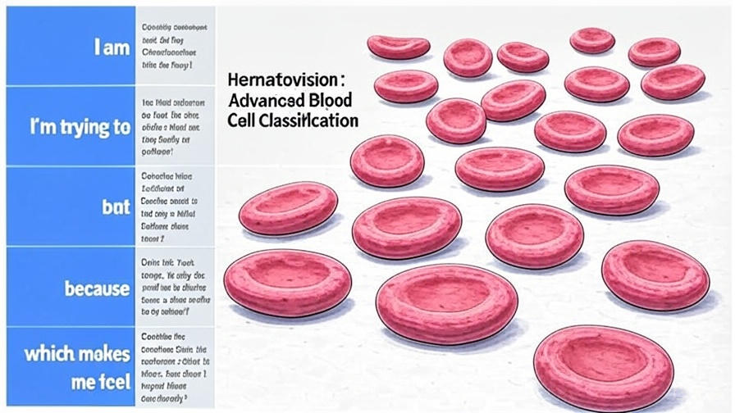

Reference: <https://miro.com/templates/customer-problem-statement/>

**Example:** 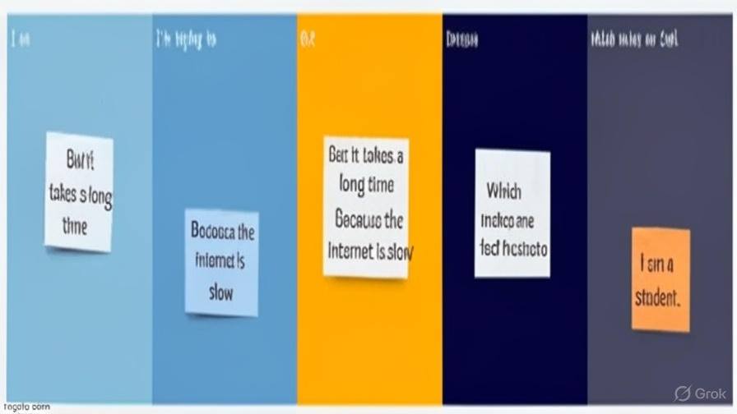

|  |  |  |  |  |  |
| --- | --- | --- | --- | --- | --- |
| **Problem Statement (PS)** | **I am (Customer)** | **I’m trying to** | **But** | **Because** | **Which makes me feel** |
| PS-1 | I am a hematologist with expertise in blood analysis, a focus on precision, and a need for efficient tools. | I’m trying to accurately classify blood cells to diagnose diseases quickly and reliably. | But the manual classification process is slow, error-prone, and struggles with rare cells. | Because current methods lack advanced automation and precision for complex cell variations. | Which makes me feel frustrated and anxious about delays and misdiagnoses. |
|  |  |  |  |  |  |